Unit Testing → Integration Testing → System Testing → User Acceptance Testing
(UAT).

Quality Assurance and Quality Control
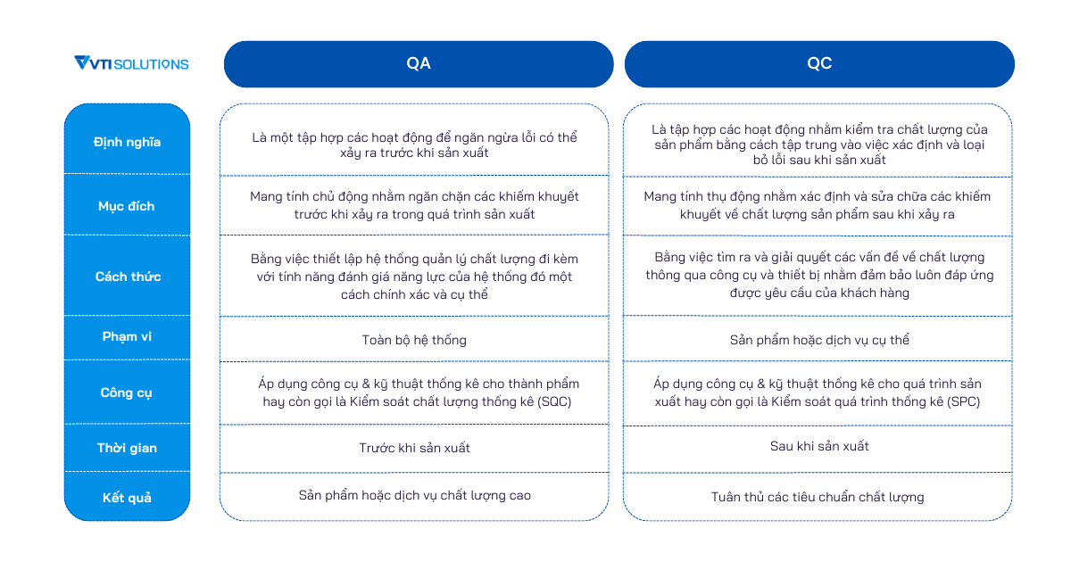
There are 10 Knowledge Areas in the PMBOK Guide:
- Project Integration Management
- Project Scope Management
- Project Time Management
- Project Cost Management
- Project Quality Management
- Project Resource Management
- Project Communication Management
- Project Risk Management
- Project Procurement Management
- Project Stakeholder Management
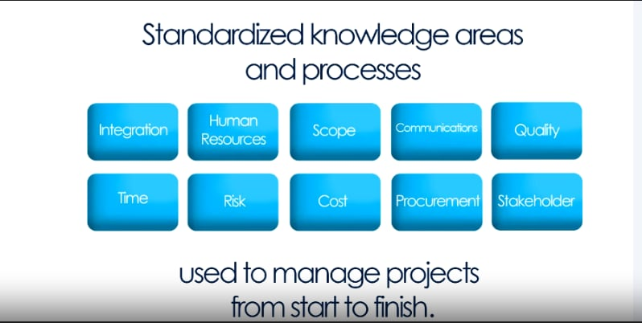
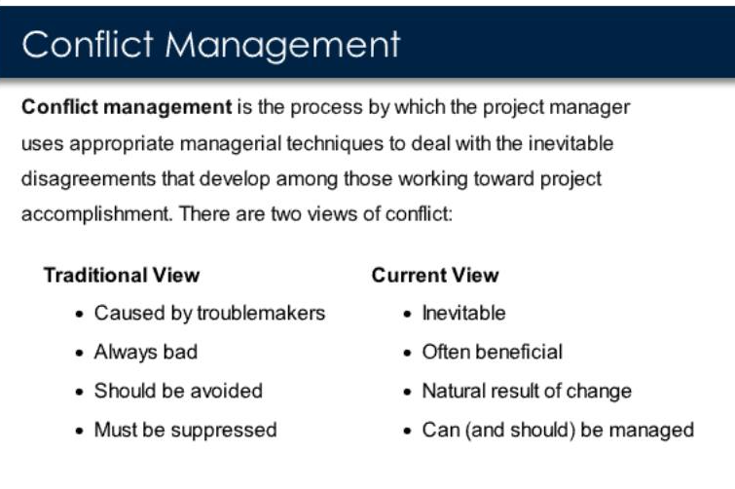
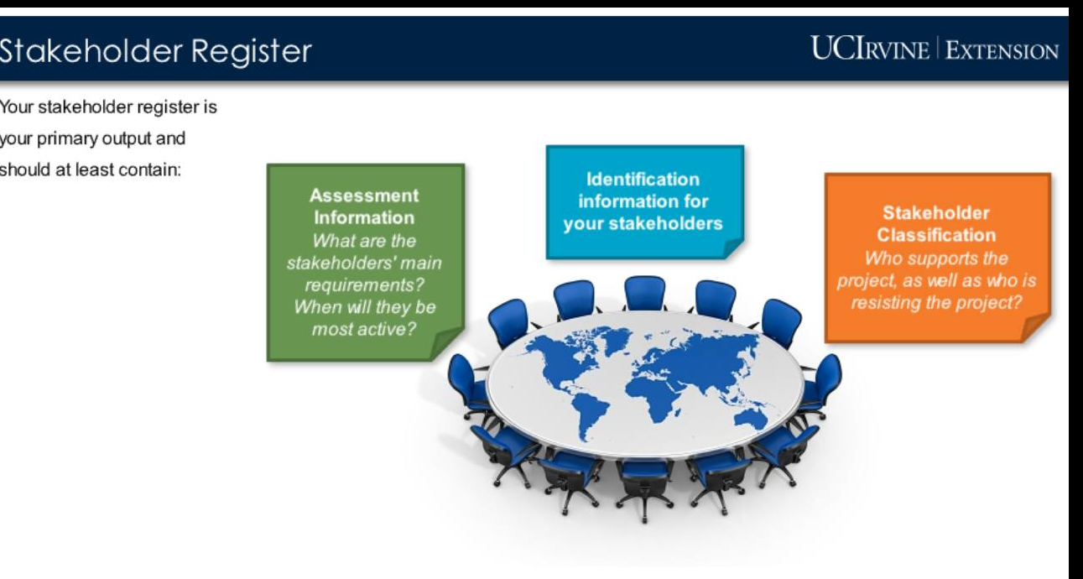

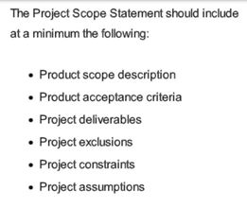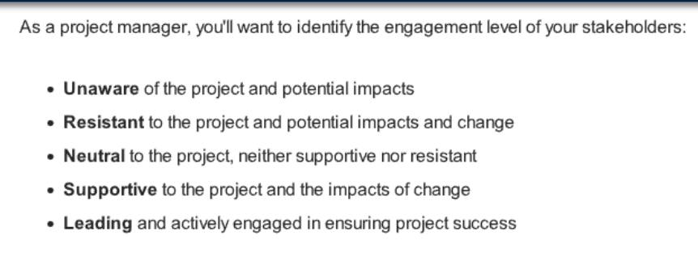
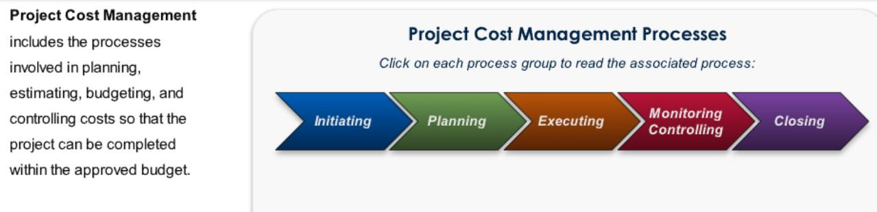
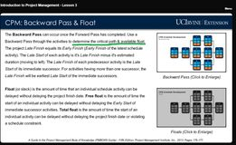
Forward pass = determine total duration
Backward pass = determine critical path & available float

